Syracuse University

Office of Sponsored Programs

[*http://www.osp.syr.edu/*](http://www.osp.syr.edu/)

**NIH RPPR Summary Guidance**

This summary document is intended to be utilized as a guidance tool for PIs and/or delegates to create and prepare NIH progress reports in the RPPR format. The sections of this document follow the NIH RPPR Instruction Guide very closely, but in a more concise manner. This document is not meant to replace the NIH RPPR Instruction Guide, but rather should be viewed as a summary companion guide. NIH has prepared extensively detailed training materials that should be consulted as the authoritative source, located here: <https://grants.nih.gov/grants/rppr/>

**RPPR Background Information and Getting Ready**

* RPPR data fields are specific to your grant. This means that active fields in the report are applicable to your grant. Data fields that are not applicable will be grayed out or labeled “Not Applicable.”
* RPPR submissions will be pre-populated with information in many areas from various databases, proposals and previous RPPR submissions. There will be opportunity to correct pre-populated information if not correctly stated, in the source database or by contacting eRA Help Desk at, [eRA Help Desk web ticketing system](https://public.era.nih.gov/commonshelp) , <http://era.nih.gov/help/>, or by phone at (301)-402-7469.
* RPPR Attachment uploads are required as individual PDF files (i.e. – no bundling of multiple PDFs).
* Data fields and text entry boxes only support ASCII characters, special characters and ‘rich text’ will not display properly.
* If a question is not applicable to your grant, or if there is no change to report, select “Nothing to Report.”
* Ensure that all project personnel that have worked 0.5 months or more on the project during the reporting period have an eRA Commons ID, including graduate and undergraduate students.
* **Give yourself plenty of time to prepare, and consult OSP for assistance, as needed.**

**Accessing the RPPR**

PD/PI or Delegate will Login to the eRA Commons and select the Status or RPPR tab in Commons. For guidance on delegating RPPR rights, please see: <http://era.nih.gov/erahelp/commons/default.htm#cshid=1012>

* If accessing from Status tab Select the List of Applications/Grants:
  + Locate the grant and select the RPPR link under Action

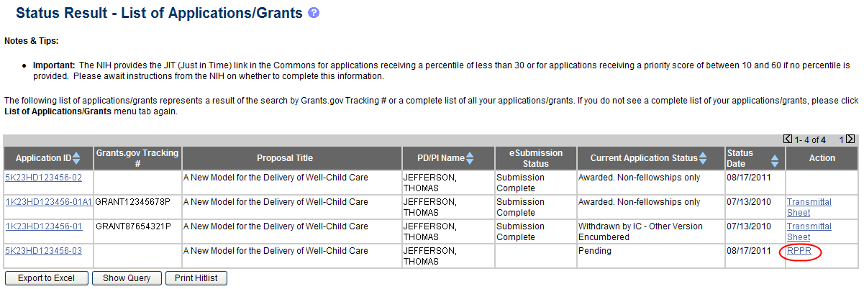

* If accessing from RPPR tab Select the List of Applications/Grants; select the specific grant by clicking the hyperlink in the Grant Number column on the Manage RPPR screen

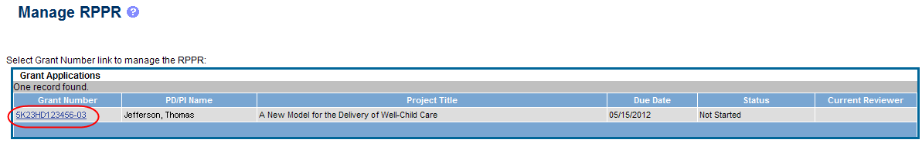

* Select RPPR then Select Initiate

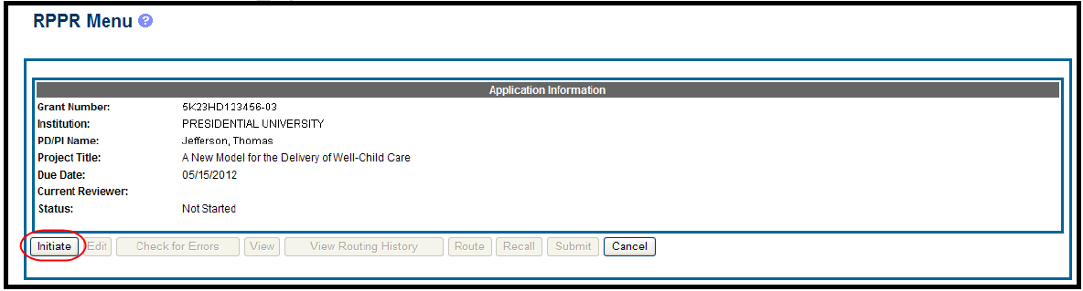

* Another screen displays; Select Edit

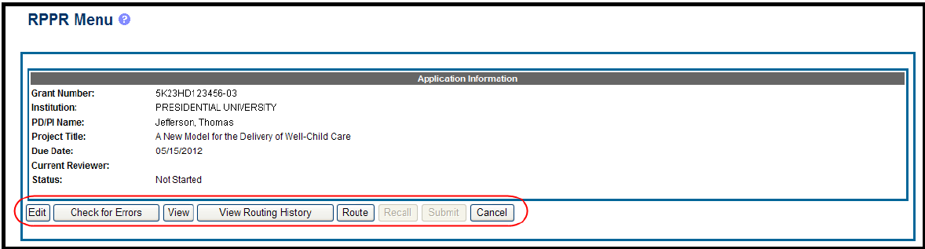

* Cover Page will appear for the RPPR. The *Cover Page* includes tabs at the top and links at the bottom of the page for navigating to the other sections (e.g., **Accomplishments, Participants**), which may be completed in any order. Before navigating to and from any of these sections, it is always necessary to select the **Save** button to save all changes on the current page. Navigating away from any page on the RPPR without selecting **Save** results in the loss of any information entered prior to the last save.



**Preparing the RPPR**

* Summary guidance organized by section.

|  |  |
| --- | --- |
| **Section** | **Instructions** |
| **A. Cover Page** | * Most of the information on the Cover Page is pre-populated from data in NIH systems, but certain fields are editable. Please review carefully and make any required changes. * Recipient ID field is not mandatory * **A.2** and **A.3** select your assigned [OSP RA](http://www.osp.syr.edu/Sponsored%20Programs%20Resources/The%20Office%20of%20Sponsored%20Programs/OSP%20Staff/who-do-you-work-with-at-osp.html) as the Administrative and the Signing Officials. |
| **B. Accomplishments** | **B.1. What are the major goals of the project?**   * Major Goals are equivalent to specific aims from the submitted proposal. Significant changes in the goals require prior approval of the agency (e.g., NIH Grants Policy Statement, 8.1.2). * The specific aims need only be entered to the first RPPR filing. In subsequent RPPRs this section will pre-populate with the aims/goals previously entered, and may be amended by answering ‘Yes’ to question B.1.a. * **NIH recommended length is up to 1 page. Limit is 8000 characters or approximately 3 pages**   **B.1.a. Have the major goals changed since the initial competing award or previous report?**Select, **Yes or No**   * If the major goals/specific aims have changed since the initial competing award or previous report, provide a revised description of major goals/specific aims. |
| ***B.2 What was accomplished under these goals?*** | For this reporting period describe:  **1)** Major Activities; **2)** Specific Objectives; **3)** Significant Results, including major findings, developments, or conclusions (both positive and negative); and **4)** Key Outcomes or Other Achievements.   * Include a discussion of stated goals not met. As the project progresses, the emphasis in reporting in this section should shift from reporting activities to reporting accomplishments. * **Response should not exceed 2 pages** |
| ***B.3 Competitive Revisions/Administrative Supplements.*** | For this reporting period, is there one or more Revision/Supplement associated with this award for which reporting is required? Select, **Yes or No**   * If yes, identify the Revision(s)/Supplements(s) by grant number or title. **1)** Describe the specific aims. **2)** Describe the accomplishments for this Revision/Supplement funded during this reporting period. * **Limit is 700 characters or approximately ¼ of a page for each question** |
| ***B.4 What opportunities for training and professional development has the project provided?***  *This is required for grants with training component (e.g. - T, F, K, R25, R13, D43 or other training awards)* | * For all projects reporting graduate students and/or postdoctoral participants in Section D. Participants (as defined in D.2.b.), describe the use of Individual Development Plans (IDPs) for those participants, but don’t include the entire IDP; rather provide information about how the IDPs are used to manage training activities. For additional information see NIH Notice: [NOT-OD-13-093](http://grants.nih.gov/grants/guide/notice-files/NOT-OD-13-093.html) * If the research is not intended to provide training and professional development opportunities or there is nothing significant to report during the reporting period, select, **Nothing to Report**. * Describe opportunities for training and professional development provided to project personnel or anyone who was involved in the activities supported by the project. * Include participation in conferences, workshops, and seminars not listed under major activities. * **Limit the response to this reporting period** |

|  |  |
| --- | --- |
| **Section** | **Instructions** |
| ***B.5 How have results been disseminated to communities of interest?*** | * Describe how the results have been disseminated to communities of interest. * For awards not designed to disseminate information to the public or conduct similar outreach activities, a response is not required and the grantee should select, **Nothing to Report**. * A detailed response is only required for awards or award components that are designed to disseminate information to the public or conduct similar outreach activities. * Please Note: “Routine” websites, press releases, and scientific publications ***do not*** apply here; but rather should be entered in Section C. Products. * **NIH recommended length is up to 1 page. Limit is 8000 characters or approximately 3 pages** |
| ***B.6 What do you plan to do for the next reporting period to accomplish the goals?*** | * Describe briefly what you plan to do during the next reporting period to accomplish the goals and objectives. * Note that significant changes in objectives and scope require prior approval of the agency. * Include any important modifications to the original plans. * Provide a scientific justification for any changes involving research with human subject or vertebrate animals. A detailed description of such changes must be provided under Changes. * **NIH recommended length is up to 1 page. Limit is 8000 characters or approximately 3 pages** |
| **C. Products**  ***C.1 Publications*** | ***Are there publications or manuscripts accepted for publication in a journal or other publication (e.g., book, one-time publication, monograph) during the reporting period resulting directly from the award?* Yes or No**   * If there are no publications to report during this reporting period, select **No**. * If **Yes*,*** this is the only section to report on Publications. Publications entered elsewhere in the RPPR will not be recorded as publications. * All publications in this section are drawn from MyNCBI site. The PIs MyNCBI account and eRA Commons accounts must be linked, otherwise the publications section will not pre-populate. * If publications are not in compliance with NIH Public Access Policy (e.g. - does not have a valid PMCID number), you can still submit the RPPR, and you will have 10 business days to update the publications for MyNCBI compliance. * For more information on MyNCBI: [http://www.ncbi.nlm.nih.gov/books/NBK3842/#MyNCBI.Getting_Started](http://www.ncbi.nlm.nih.gov/books/NBK3842/%23MyNCBI.Getting_Started) |
| ***C.2 Website(s) or other internet site(s).*** | * For awards not designed to create or maintain one or more websites, select **Nothing to Report**. A description is only required for awards designed to create or maintain one or more websites. * List the URL for any Internet site(s) that disseminates the results of the research activities and include a short description of each site. * It is not necessary to include the publications already specified above under C.1. * **NIH recommended length is up to 1 page. Limit is 8000 characters or approximately 3 pages. Limit the response to this reporting period.** |
| ***C.3 Technologies or techniques.*** | * Identify technologies or techniques that have resulted from the research activities. Describe the technologies or techniques and how they are being shared. * If none, select **Nothing to Report.** * **NIH recommended length is up to 1 page. Limit is 8000 characters or approximately 3 pages. Limit the response to this reporting period.** |
| ***C.4 Inventions, patent applications and/or licenses.*** | * Have inventions, patent applications and/or licenses resulted from the award during this reporting period? **Yes or No** * If **Yes**, has this information been previously provided to the PHS or to the official responsible for patent matters at the grantee organization? **Yes or No** |

|  |  |
| --- | --- |
| **Section** | **Instructions** |
| ***C.5 Other products and resources.*** | ***C.5 .a Other products –***   * Identify any other significant products that were developed under this project. Examples of other products are: audio or video products; data and research material, educational aids, etc. * Describe the project and how it is available to be shared with the research community. * Do not repeat information provided above. * If none select **Nothing to Report.** * **Limit the response to this reporting period**   ***C.5.b Resource Sharing –***   * PD/PIs and grantee organizations are expected to make the results and accomplishments of their activities available to the research community and to the public at large. * If the initial research plan addressed, or the terms of award require, a formal plan for sharing final research data, model organisms, Genome Wide Association Studies data, or other such project-specific data, describe the progress in implementing the plan. * If the sharing plan is fully implemented; provide a final statement on data sharing. * If none select **Nothing to Report.** |
| **D. Participants (project personnel)**  ***D.1 What individuals have worked on the project?***  *Note: The requirement for NIH Commons IDs for project personnel now includes undergraduate and graduate students. RPPR warnings will begin in October 2013, and will be RPPR requirement effective October 2014 (i.e. – would prevent submission)* | * Provide or update the following information for: **(1)** program director(s)/principal investigator(s) (PDs/PIs); and **(2)** each person who has worked at least **one person month** per year on the project during the reporting period, regardless of the source of compensation (a person month equals approximately 160 hours or 8.3% of annualized effort). * Provide the name and identify the role the person played in the project. * Indicate the nearest whole person month that the individual worked on the project (i.e. 0-0.4 months is reported as (0), 0.5 – 0.9 months is reported as (1). * Show the most senior role in which the person has worked on the project for any significant length of time (e.g. - if an undergraduate student graduates, enters graduate school, and continues to work on the project, show that person as a graduate student.) * **Is the individual’s primary affiliation with a foreign organization? Yes or No** * If **Yes**, provide the name of the organization and country. |
| ***D.2 Personnel Updates.***  ***D.2.a Level of effort.*** | *Will there be, in the next budget period, either* ***(1)*** *a reduction of 25% or more in the level of effort from what was approved by the agency for the PD/PI(s) or other senior/key personnel designated in the Notice of Award, or* ***(2)*** *a reduction in level of effort below the minimum amount of effort required by the Award?* **Yes or No**   * If **Yes**, provide an explanation * **Limit is 700 characters or approximately ¼ of a page** |
| ***D.2.b New senior/key personnel.***  *Note: Senior/key personnel are those identified by SU as contributing in a substantive measurable way to the scientific**development or execution**of the project* | ***Are there, or will there be, new senior/key personnel?* Yes or No**   * If **Yes,** upload biosketchs and other support for all new senior/key personnel. * Annotate changes in other support within the other support at the end of each key personnel listed. |
| ***D.2.c Changes in other support.*** | ***Has there been a change in the active other support of senior/key personnel since the last reporting period?* Yes or No**   * If **Yes**, upload active other support for senior/key personnel whose support has changed and indicate what the change has been. |
| ***D.2.d New other significant contributors.*** | ***Are there, or will there be, new other significant contributors?* Yes or No**   * If **Yes,** upload biosketchs for new other significant contributors. |

|  |  |
| --- | --- |
| **Section** | **Instructions** |
| ***D.2 e Multi-PI (MPI) Leadership Plan*** | ***Will there be a change in the MPI Leadership Plan for the next budget period?*** **Yes, No or N/A**.   * If **Yes**, upload a revised MPI Leadership Plan that includes a description of the change(s). * Note that change in status of PD/PI requires prior approval of agency (e.g., NIH Grants Policy Statement 8.1.2.6). |
| **E. Impact** |  |
| ***E.1 What is the impact on the development of human resources?*** | * Not Applicable for most awards * Only applicable to education awards (D24, K30, R13, R25, RL5, T14, T36, U13, U2R) |
| ***E.2 What is the impact on physical institutional or information resources that form infrastructure?*** | * Describe ways, if any, in which the project made an impact, or is likely to make an impact, on physical, institutional, and informational resources that form infrastructure. * If the award is not intended to support physical, institutional, or information resources that form infrastructure, select **Nothing to Report**. * **NIH recommended length is up to 1 page. Limit is 8000 characters or approximately 3 pages** |
| ***E.3 What is the impact on Tech. Transfer?*** | * Not Applicable for most awards |
| ***E.4 What dollar amount of the award’s budget is being spent in foreign country(ies)?*** | * Dollars provided should reflect total costs. * **If more than one foreign country, identify the distribution between the foreign countries.** * Report only cumulative ***first-tier subaward*** dollars by country. * Do not report foreign travel, purchases, etc., unless part of a first-tier subaward to a foreign country. If none select **Nothing to Report.** |
| **F. Changes** |  |
| ***F.1 Changes in Approach?*** | * Not Applicable for most awards |
| ***F.2 Actual or anticipated challenges or delays and actions or plans to resolve them.*** | * Describe challenges or delays encountered during the reporting period and actions or plans to resolve them. * Describe only significant changes that may impede the research (e.g. accrual or patients, hiring or personnel, need for resources or research tools) and emphasize their solution. If none select **Nothing to Report.** * **NIH recommended length is up to 1 page. Limit is 8000 characters or approximately 3 pages.** |
| ***F.3 Significant changes to human subjects, vertebrate animals, biohazards, and/or select agents.*** | * Describe significant deviations, unexpected outcomes, or changes in approved protocols for human subjects, vertebrate animals, biohazards and/or select agents during this reporting period. |
| ***F.3.a Human Subjects*** | * If human subject protocols are or will be different from the previous submission, include a description and explanation of how the protocols differ and provide a new or revised Protection of Human Subjects Section as described in the competing application instructions. If none, select **No Change.** |
| ***F.3.b Vertebrate Animals*** | * If there are or will be significant changes to the uses of vertebrate animals from the previous submission, provide a description of the changes. If none, select **No Change.** |
| ***F.3.c Biohazards*** | * If the use of biohazards is or will be different from that in the previous submission, provide a description and explanation of the difference(s). If none, select **No Change.** |

|  |  |
| --- | --- |
| **Section** | **Instructions** |
| ***F.3 d Select Agents*** | * If the possession, use, or transfer of Select Agents is or will be different from that proposed in the previous submission, provide a description and explanation of the differences. * If the use of Select Agents was proposed in the previous submission but has not been approved by regulatory authorities, provide an explanation. * If studies involving Select Agents are planned and were not part of the original proposed research design, provide a description of the proposed use, possession, transfer, and research location as described in the competing applications instructions. If none, select **No Change.** * Link: <http://www.selectagents.gov/Select%20Agents%20and%20Toxins.html> |
| **G. Special Reporting Requirements** |  |
| ***G.1* *Special Notice of Award and Funding Opportunity Announcement Reporting Requirements*** | * Address any special reporting requirements specified in the award terms and conditions in the Notice of Award (NOA) or Funding Opportunity Announcement (FOA). If none, select **Nothing to Report.** |
| * 1. ***Not Applicable to most awards.***   2. ***Not Applicable to most awards*** | * Only applicable to K, F and other education awards * Only applicable to K, F awards |
| ***G.4. Human Subjects***  ***G.4.a Does the project involve human subjects?*** | * If activities involving human subjects are planned at any time during the next budget period at the grantee organization or at any other project/performance site or collaborating institution, select **Yes**. * Select **Yes** even if the project is exempt from the Regulations for the Protection of Human Subjects. * Select **No** if activities involving human subjects are not planned at any time during the next budget period. |
|  | * **Is the research exempt from federal regulations?** Not applicable unless the answer to **G.4.a.** is **Yes**. |
|  | **Does this project involve a clinical trial?** Not applicable unless the answer to **G.4.a.**, is **Yes**.   * **If Yes, is this an NIH defined Phase III Clinical Trial?** |
| ***G4.b Inclusion enrollment data.*** | * Unless otherwise notified by the program official**,** reporting the cumulative enrollment of subjects and the distribution by sex/gender, race, and ethnicity is required for NIH-defined clinical research. * ***In Section F.3.a., please describe details or concerns related to your inclusion enrollment progress*** |
| ***G.4c ClinicalTrial.gov*** | **Does this project include one or more applicable clinical trials that must be registered in ClinicalTrials.gov under FDAAA? Yes or No**   * If Yes, provide the ClinicalTrials.gov identifier, NCT number (e.g. NCT 00654321) for those trials. |
| ***G.5 Human Subjects Education Requirement.*** | **Are there personnel on this project who are or will be newly involved in the design or conduct of human subjects’ research?** If **Yes**, provide the following:   * Names of individuals, * Title of the human subjects education program completed by each individual, and a one-sentence description of the program. * **Limit is 1300 characters or approximately ½ of a page** |

|  |  |  |  |
| --- | --- | --- | --- |
| **Section** | **Instructions** | | |
| ***G.6 Human Embryonic Stem Cells (hESCs).*** | **Does this project involve human embryonic stem cells? Yes or No**   * Only hESC lines listed as approved in the [NIH Registry](http://grants.nih.gov/stem_cells/registry/current.htm?sort=rnd) may be used in NIH funded research. * If **Yes**, identify the hESC Registration number(s) from the NIH Registry. * If there is a change in the use of hESCs provide an explanation. * **Limit is 700 characters or approximately ¼ of a page** | | |
| ***G.7 Vertebrate Animals*** | **Does this project involve vertebrate animals? Yes or No (This should pre-populate)** | | |
| ***G.8 Project/Performance Sites.*** | **If there are changes to the project/performance site(s) displayed, edit as appropriate.** | | |
| ***G.9 Foreign component.*** | * Provide the organization name, country, and description of each foreign component. | | |
| ***G.10 Estimated unobligated balance.***  ***G.10.a***  ***Is it anticipated that an estimated unobligated balance (including prior year carryover) will be greater than 25% of the current year’s total approved budget? Yes or No*** | * The *total approved budget* equals the current fiscal year award authorization plus any approved carryover of funds from a prior year(s). The numerator equals the total amount available for carryover and the denominator equals the current year’s total approved budget. * If **Yes,** provide the estimated unobligated balance. * ***G.10.b Provide an explanation for unobligated balance.*** * **Limit is 700 characters or approximately ¼ of a page** | | |
| ***G.10.c If authorized to carryover the balance, provide a general description of how it is anticipated that the funds will be spent.*** | * **To determine carryover authorization, see the Notice of Award.** * Grantees not authorized to carryover unobligated balances automatically must submit a prior approval request to the awarding IC. * **Limit is 1300 characters or approximately ½ of a page** | | |
| ***G.11 Program Income.*** | **Is program income anticipated during the next budget period? Yes or No**   * If **Yes**, provide the amount and source(s). | | |
| ***G.12 F&A Costs*** | **Is there a change in performance sites that will affect F&A costs? Yes or No** |  |  |
| * **[applicable to SNAP awards only]** * If **Yes**, provide an explanation. * **Limit is 1300 characters or approximately ½ of a page** | | |
| **H. Budget** | * **[when implemented, applicable to non-SNAP awards only]** | | |

**Final Steps**

* + Perform the ‘**Check for Errors’** function to determine what areas of the report may require correction prior to submission. This can be performed by anyone with access to the RPPR at any time during the process. NIH will not permit submission of the RPPR until all errors are corrected.
  + **Route to the ‘Signing Official’** (OSP Research Administrator) once all errors have been corrected and the PI/PD is satisfied the RPPR is final. ***Note:*** that only the PI/PD can route to Signing Official, not a delegate.
  + OSP Research Administrator will review the RPPR to ensure that all sections are complete and error free, and either **Submit the RPPR** or go back to the PI/PD with questions or clarifications prior to submission.